Section 3 : Tradition Collection
https://www.beautifulhomes.asianpaints.com/sleek-kitchens.html
https://ibaxindia.com/
 -> Explore now

- Modular Kitchen
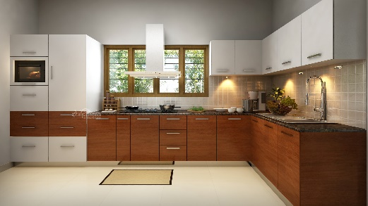
Category:
    - pantry unit
    - rolling shutter
    - oil pull out
    - cutlery tray
    - blind corner - swing corner

2.glass partition
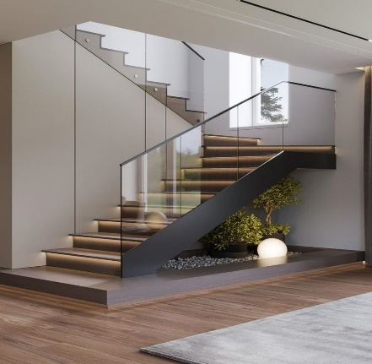

Category:
- Staircase Railing
- Balcony railing
- Shower Partitions
- Telescopic - sliding
- Fixed Partition

- Wardrobes

